USK VALLEY WORKING GUNDOG CLUB (ID718)

RESULTS OF WORKING TESTS 2013
Once again, we held our Skinner's Challenge this year (the dog with the most points across all 4 tests), and are delighted to announce that the Winner for 2013 is Claire Raymond with FTCh Levenghyl Beetle who will receive a Skinner's bag of dog food and an embroidered fleece. Congratulations and well done to Claire!

Retriever Working Tests at Glanusk - 31st August
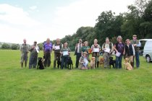 | 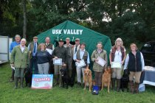
Novice & Puppy | Open

The results were as follows:-
Novice |  |  | Open
1st | Hassycott Whistlefish Fin | Mr M Redpath | 1st | FTCh Vamp Parsley Potage | Mrs V Prichard
2nd | Mucklehart Gracie | Ms D Cornforth | 2nd | Shuttifield Sinbad | Mr M Redpath
3rd | Wapsac Major of Llanover | Mr D James | 3rd | Cadover Bumble of Craigfelin | Mr R Tozer
4th | Skeviot Starlite | Ms C Jenkins | 4th | Slipside Diplomat | Mrs D Bird
 |  |  | COM | Luisenga Highland Lad | Mr P Hobbs
 |  |  | COM | Lilleburne Ripple Reed | Mrs M Jarrod
Puppy
1st | Buffskin Zelda | Mrs V Emms
2nd | Tuckers Pool Joy of Vamp | Mrs V Prichard
3rd | Mynyddmaen Misti | Mr J Derrick

Retriever Working Tests at Trippen Kennett - 18th August
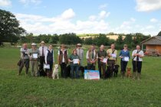 | 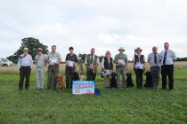
Novice | Open
The results were as follows:-
Novice |  |  | Open
1st | Ffynongain Usher | Mr M Stevens | 1st | Saxaphone John Smiths | Ms E Bos
2nd | Windoog Pack Coral | Ms C Baker | 2nd | FTCh Levenghyl Beetle | Mrs C Raymond
3rd | Skeviot Starlite | Ms C Jenkins | 3rd | Slipside Danzy Jones | Mr N Probert
4th | Copperbirch Gunner | Mr N Probert | 4th | Shuttifield Gracon | Mrs J Redpath
COM | Hassycott Whistlefish Finn | Mr M Redpath | COM | Vamp Pipsissewa | Mr A Fisher
COM | Jarailstar Biscuit | Ms C Haywood
COM | Movenne Dark Knight | Mrs C Raymond

Retriever Working Tests at Clytha Park - 9th June
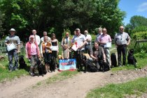 | 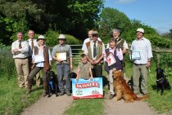
Novice & Puppy | Open
The results were as follows:-
Novice |  |  | Open
1st | Cynhinfa Lennon | Mr C Perry | 1st | FTCh Vamp Parsley Potage | Mrs V Prichard
2nd | Movenne Arrow of Greyhill | Mrs G Wright | 2nd | FTCh Levenghyl Beetle | Mrs C Raymond
3rd | Tereshenko Duke Joseph | Mrs V Oakley | 3rd | Slipside Danzy Jones | Mr N Probert
4th | Millay Summer Rose | Mr J Saxton | 4th | Oncote Mystic Millie of Gallfield | Mr D Gallimore
COM | Copperbirch Gunner | Mr N Probert
Puppy
1st | Ryford Amethyst | Mrs J Beach
2nd | Tan y Rhallt Clorin | Mrs V Oakley
3rd | Mynyddmaen Non | Mr J Derrick
4th | Endacott Todd for Lovehayne | Mr R Edwards
COM | Cynhinfa Marcus | Miss B James

Spaniel Working Tests at Manmoel - 25th May
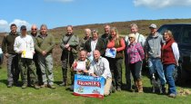
Award Winners
The results were as follows:-
Novice |  |  | Open
1st | Minnie | Jeff McAndrew | 1st | Shalloak West Stag | Alistair Ross
2nd | Murrayden Apollo | Jane Smith | 2nd | Gatekeeper Lady | Jane Stenner
3rd | Cippin Nutmeg | Matthew Jones | 3rd | Copperspring Purdy | Helen Clarke
4th | Ladecourt Slip of Shalloakwest | Alistair Ross | 4th | Glanhowy Grankly Scarlet | Peter Moruzzi
COM | Tina | Jeff McAndrew | COM | Cippyn Rainbow | Matthew Jones
COM | Sneggy Kaylon | Michael Hurley | COM | Izzy | Jeff McAndrew
COM | Creccamarsh Jessie | Mason Jones
COM | Rosey | Paul Williams
COM | Fran | Kevin Jones
COM | Nederscot Rebel | Eric Smith
COM | Filzers Dixie | Alison Spiers
COM | Lydbrook Lad | J Derrick
COM | Caegarw Eclipse | Brian Barry
COM | Bushback Gypsy | Gavin Pearson
Retriever Working Tests at Park Farm, Caerleon - 24th March
The results were as follows:-
Novice |  |  | Open
1st | Cadover Bumble of Craigfelin | Mr R Tozer | 1st | FTCh Levenghyl Beetle | Mrs C Raymond
2nd | Ffynongain Triffer | Miss S Stevens | 2nd | Dealminster Pen | Mr H Parker
3rd | Damson of Ivy Rock | Miss E Davies | 3rd | Slipside Danzy Jones | Mr N Probert
4th | Slipside Ebony | Mr P Green | 4th | Penderyn Welsh | Mr N Probert
 |  |  | COM | Deaminster Hornet | Mrs G Hermann
Puppy
1st | Brigburn Kit Carson | Mrs S Rogers
2nd | Copperbirch Gunner | Mr N Probert
3rd | Killyryrudden Faeroe | Mrs P Gibb
4th | Karnoosty Out of Bounds | Mrs A Baker
COM | Karnoosty In the Rough | Mrs D Smith

